Coral Bleaching

A coral polyp is an animal that has tentacles with stinging cells that can capture prey. A coral polyp also has tiny algae that live inside the coral polyp’s cells. These algae carry out photosynthesis to produce sugars, which provide much of the coral polyp’s nutrition. After a coral polyp settles on a rocky surface on the ocean floor, it secretes a hard, mineral skeleton that attaches it to the rocky surface.

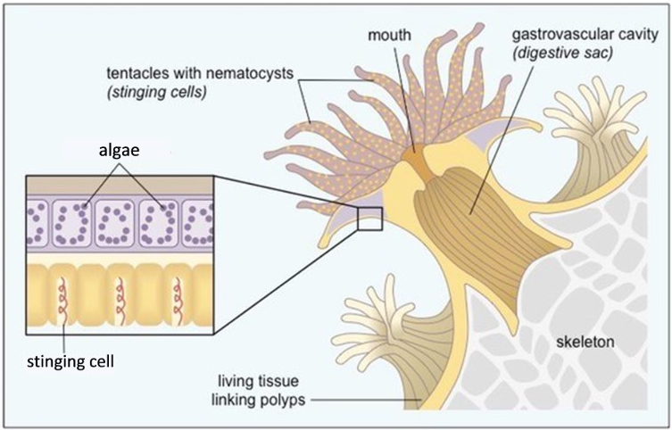

1. As a coral polyp grows, it gets longer and finally splits into two daughter polyps. This figure shows coral polyps at various stages of this type of reproduction. Indicate what the sequence of the circled polyps would be, using the numbers 1, 2 and 3 around the outside of the figure.  By this type of reproduction, a coral polyp produces daughter polyps, which produce more daughter polyps, and so on. This results in a colony of polyps, called a coral. Over many years, multiple corals build up a coral reef. | 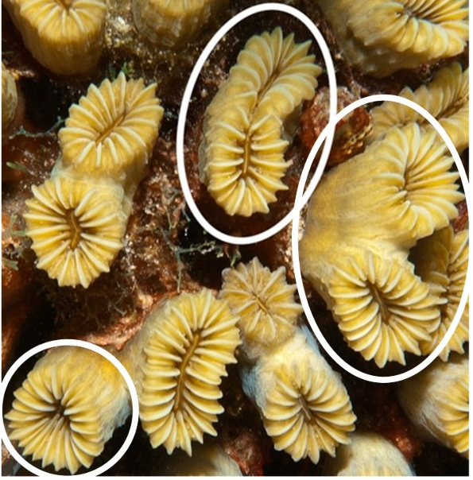

2. Complete this table to explain why a coral reef is said to be animal, vegetable, and mineral. (Here, “vegetable” refers to any photosynthetic organism.)

Animal part of coral reef
Photosynthetic organisms in coral reef
Mineral part of coral reef

In recent decades, many corals have bleached (lost their color and become white). This figure shows an example of a coral before it bleached, when it was bleached, and after it recovered. If a coral is bleached for too long, it does not recover; instead, it dies.

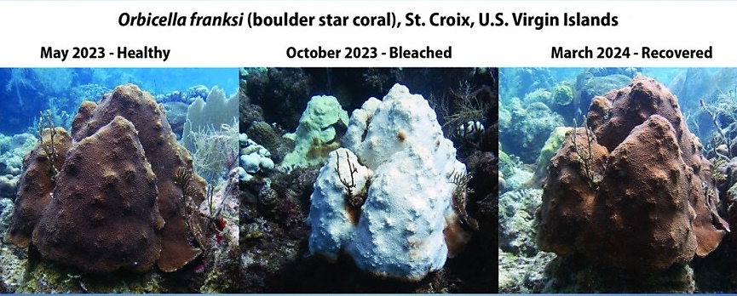

3. What questions do you have about coral bleaching?

4. Put arrows next to two or more questions that you want to research on the web. Prepare a report that includes (1) your questions, (2) the answers you have found, and (3) the sources for your answers. Your teacher will tell you what format you should use for your report and how you will share your findings with your classmates.

After the student reports, watch the video, “Coral Reefs and Climate Change” (https://www.calacademy.org/educators/coral-reefs-and-climate-change).

5. What can we do to reduce coral bleaching?

One website concludes “With respect to marine life -- and especially that of calcifying organisms such as corals… -- neither increases in temperature, nor increases in atmospheric CO2 concentration, nor increases in both of them together, have had any ill effects on the important processes of calcification and growth.” (http://co2science.org/education/reports/corals/conclusion.php). Contrary to this conclusion, much evidence indicates that increased CO₂ in the atmosphere is the primary cause of global warming, which has been a major cause of coral bleaching and death. To understand the possible motivations of the authors of this website, answer question 6.

6a. Use a web search to list some of the sponsors of the http://www.co2science.org/ website.

6b. What is a likely reason why the funders of this website would be motivated to conclude that increasing CO₂ in the atmosphere does not endanger coral reefs?

By Dr. Ingrid Waldron, Dept Biology, Univ Pennsylvania, © 2024. This Student Handout and Teacher Notes (with learning goals, instructional suggestions, and background biology) are available at https://serendipstudio.org/exchange/bioactivities/coral.

